**WHAT IS**

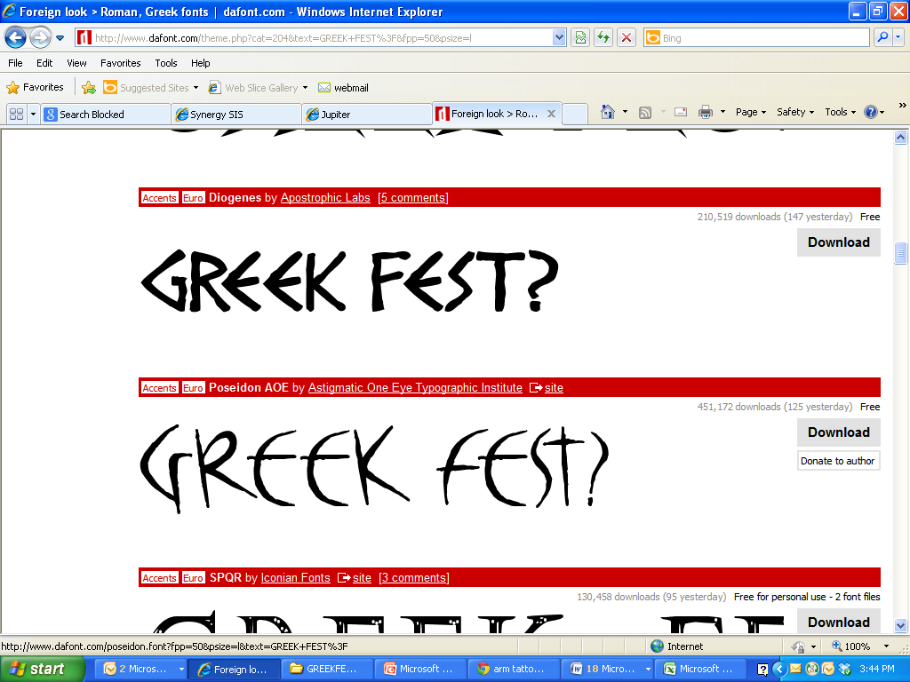

Greek Fest is the culminating activity of the 6th grade study of ancient Greece. On the day of the event, students, working in teams and dressed in togas, participate in a wide range of academic, problem-solving, and athletic activities. The day’s events also include a parade around the neighborhood and a potluck lunch.

The primary objectives of Greek Fest are for students to learn about Ancient Greece in a hands-on, experiential manner and to practice working as a team to plan and execute activities. A secondary goal is for students to have a fun-filled, memorable day of learning and play.



**May 18th**

FAMILY PARTICIPATION IN THIS EVENT IS CRUCIAL! Each of the activity stations (approximately 40) is run by a parent, grandparent, aunt, etc. Adults will also set up/clean up, serve lunch, and help with the judging.

Please look over the following pages, see how you can help out, and return your student’s permission slip and your volunteer sign-up to your child’s homeroom teacher as soon as possible.

We hope to see you at this exciting event!

The Greek Fest Committee

MCj01050080000[1]MCj01050200000[1]MCj01050060000[1]