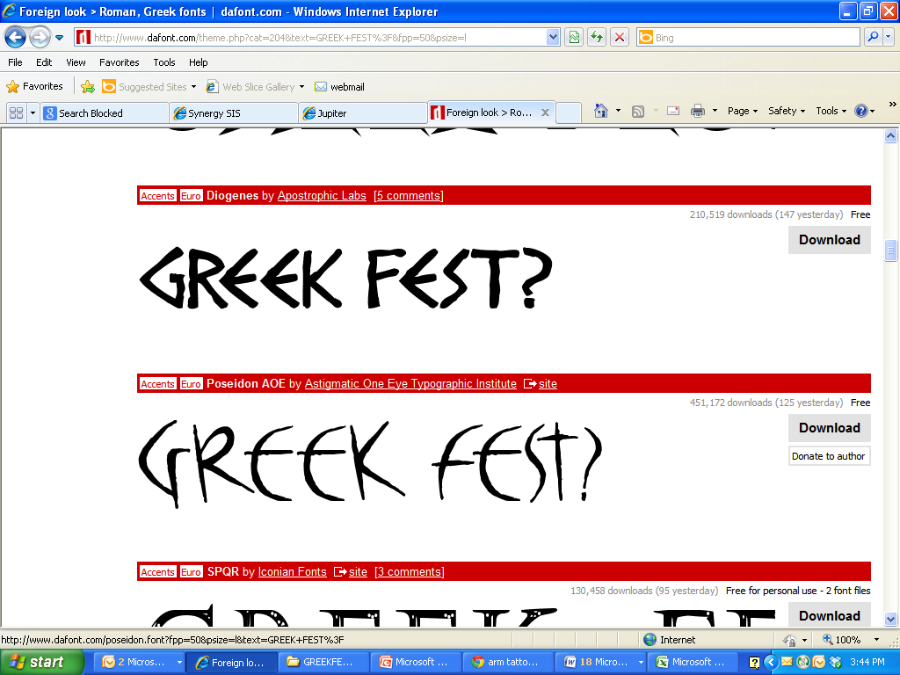

**2017 Calendar**

|  |  |
| --- | --- |
| April 3rd | Greek Fest Kick-Off Assembly for students during 1st period |
|  |  |
| April 4th-6th | Team sign-ups at lunch |
|  |  |
| April 7th | Planning time for students during  1st period |
|  |  |
| April 10th-17th | Spring break! Meet with your Greek Fest team if you are all in town. |
|  |  |
| April 21st | Parent volunteer signs ups due |
|  |  |
| May 1st | Permission slips due |
|  |  |
| May 5th | Planning time for students during  1st period |
|  |  |
| May 18th | Greek Fest 9am-2pm |
|  |  |
| May 19th | Greek Fest Awards Assembly during 1st period |

MCj01050080000[1]MCj01050060000[1]MCj01050200000[1]