C:\Documents and Settings\JChow\Local Settings\Temporary Internet Files\Content.IE5\XZBSU947\MCBL00021_0000[1].wmfC:\Documents and Settings\JChow\Local Settings\Temporary Internet Files\Content.IE5\XZBSU947\MCBL00021_0000[1].wmf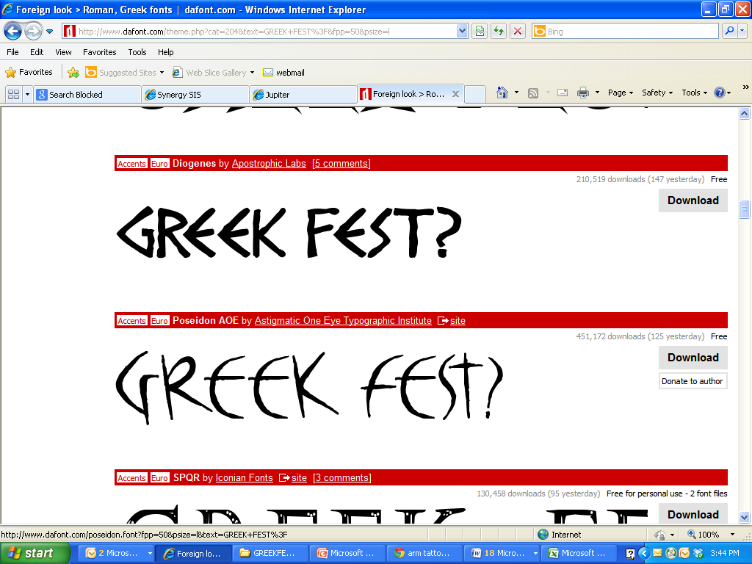

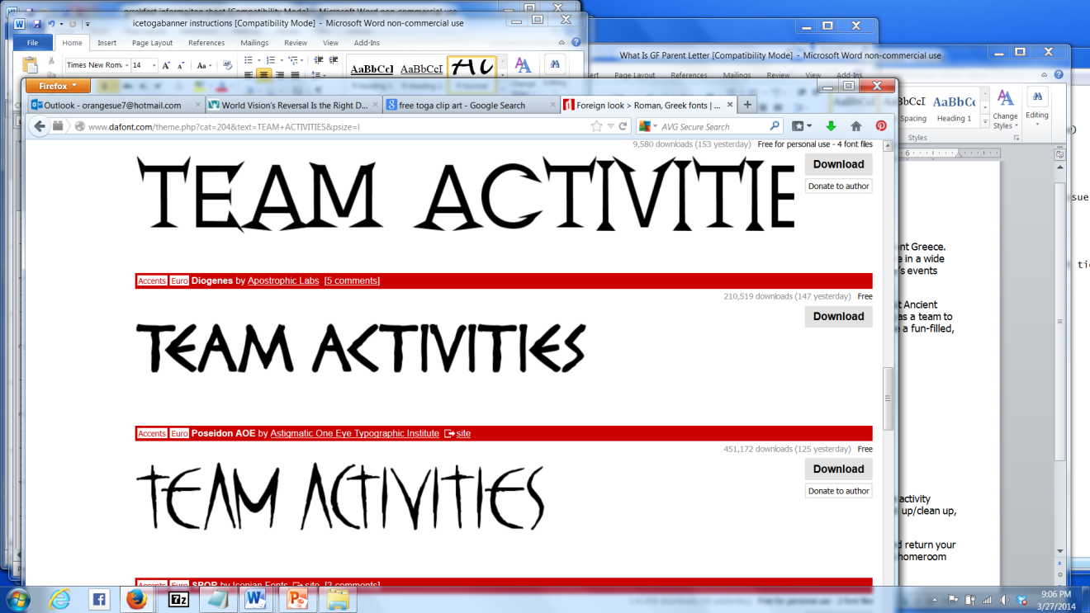

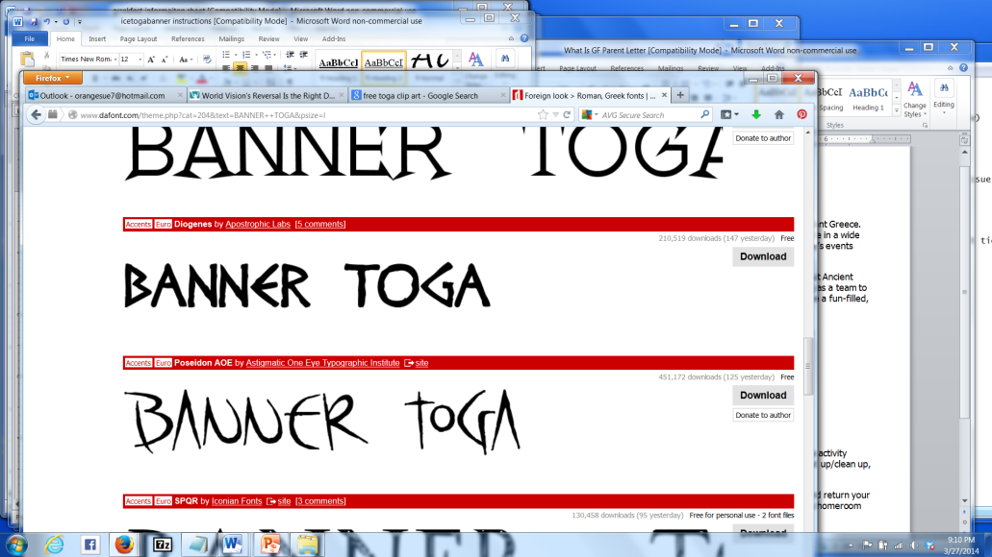

1. In order to participate in Greek Fest, all students need to wear a toga.
2. All team togas should look alike. Teams should decide on a color and design that works for the entire team.
3. Togas don’t need to be fancy; a simple white sheet or white fabric, worn as a toga was during ancient times, is sufficient.
4. Your togas cannot be purple because that is reserved for royalty (in this case, our teachers).
5. It would be wise to wear a t-shirt under your toga as it can get chilly.
6. The toga may not be strapless; it must be secured over at least one shoulder.
7. Togas should be an appropriate length -- neither too short nor too long. Students should be comfortable and able to move freely in their togas.
8. Try to come to school in your costume.
9. No student will be without. If you’re having difficulty getting a costume, let your teacher know. Just don’t wait until the last minute!

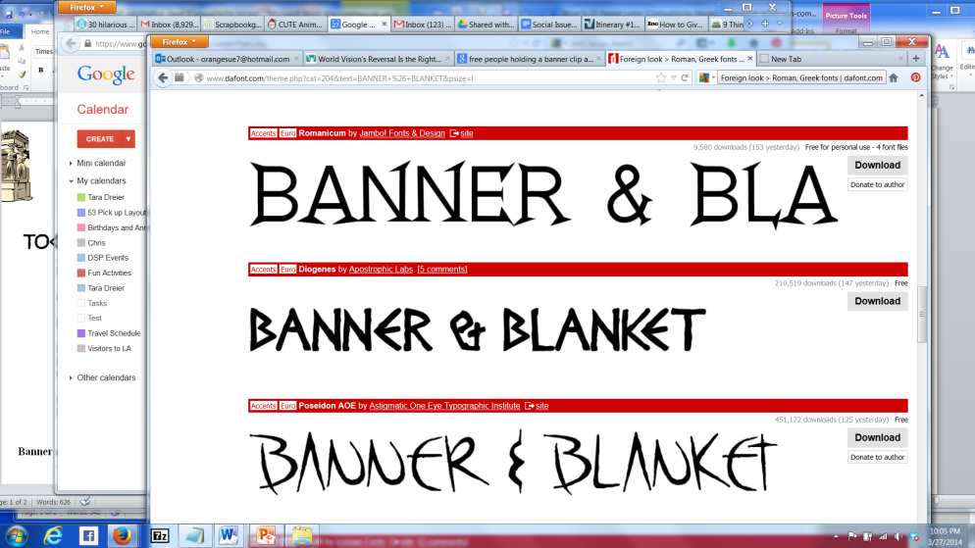

1. Each team must design and create a banner. Banners that appear to be professionally produced will be excluded from the banner competition.
2. The team name and the first name of each student on the team should be clearly visible. Incorrect spelling will eliminate your banner from the banner competition.
3. Banners can be made of cloth, paper, plastic, felt, etc.
4. Banners will be carried during the parade, so you might with to attach it to a stick(s) or pole(s) like a flag or soccer banner.
5. In addition, each team must bring ONE blanket to sit on during the events. The blanket serves as your team’s ‘home base’.

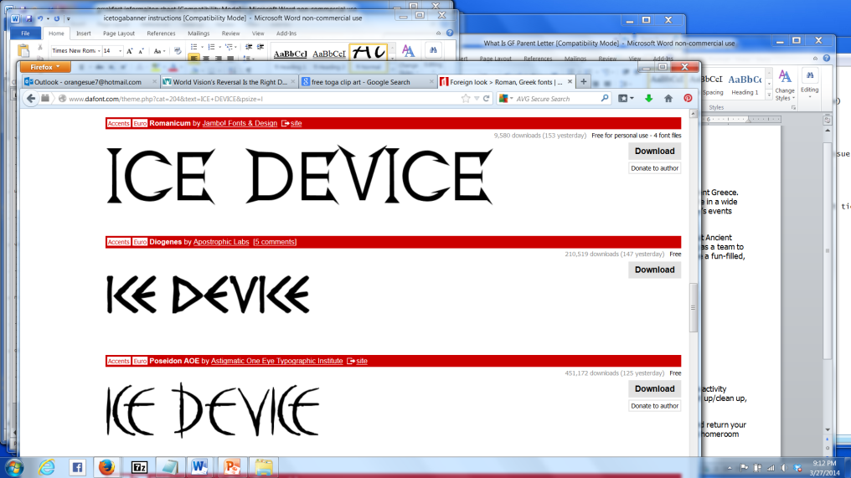

1. Each Greek Fest team needs to create one device designed to prevent an ice cube from melting.
2. The ice device is to be created by team members using ONLY materials available in Ancient Greece. Natural materials such as wood, paper, dirt, natural foods, metal, etc., are acceptable. Items like Styrofoam, plastic, foil, or other materials specifically designed to insulate were not available and cannot be used. (Example: you could use a coffee can, but not the plastic lid.)
3. The device will only contain one ice cube, so it doesn’t need to be too large. Make your device easy to carry as you will be carrying it during the parade.
4. Your team name must be clearly labeled. If the judges can’t easily see the name, your device will be disqualified.
5. Upon arrival at school, one ice cube will be given to a team member to place in the ice device. Do not come to school with your own ice cube.
6. Devices will be judged on the following: clearly labeled team name, creativity and uniqueness, and the size of the ice cube remaining at the end of the day.

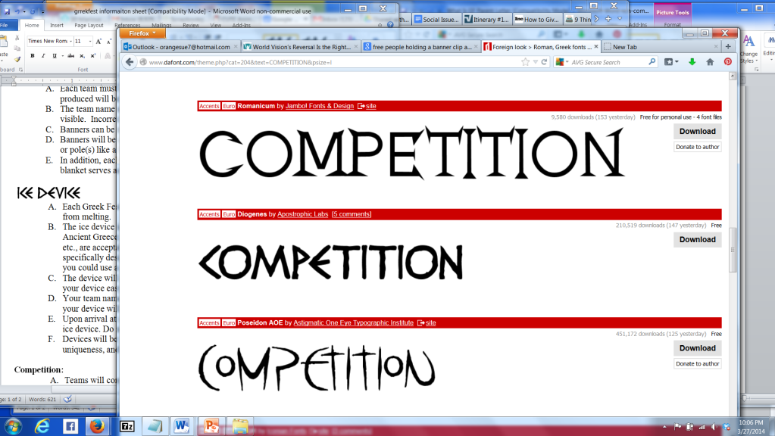

1. Teams will compete for 1st, 2nd, and 3rd place certificates in the following categories: best banner, best toga, most team spirit, best theme (how well your banner and costumes match--color, design, a common symbol, etc.), best score in the day’s events, foot races (one member from each team will run), ice device, and the Arête Award (best overall).
2. Remember that the judges prefer student-created work over perfection. Make sure that the members of your team are involved in creating everything for Greek Fest.
3. Teachers, with the help of parents, will determine the winners in each category.
4. Awards will be given at an awards ceremony during 1st period the day after Greek Fest.

You will be given two short planning sessions during school hours to meet with your group. All other planning and work must be completed outside of school.

The IBL Maker Space will be available for use by Greek Fest teams. Talk to Mrs. Miller if you would like to schedule time to work in that space.